Midlands State University Law Review 2017
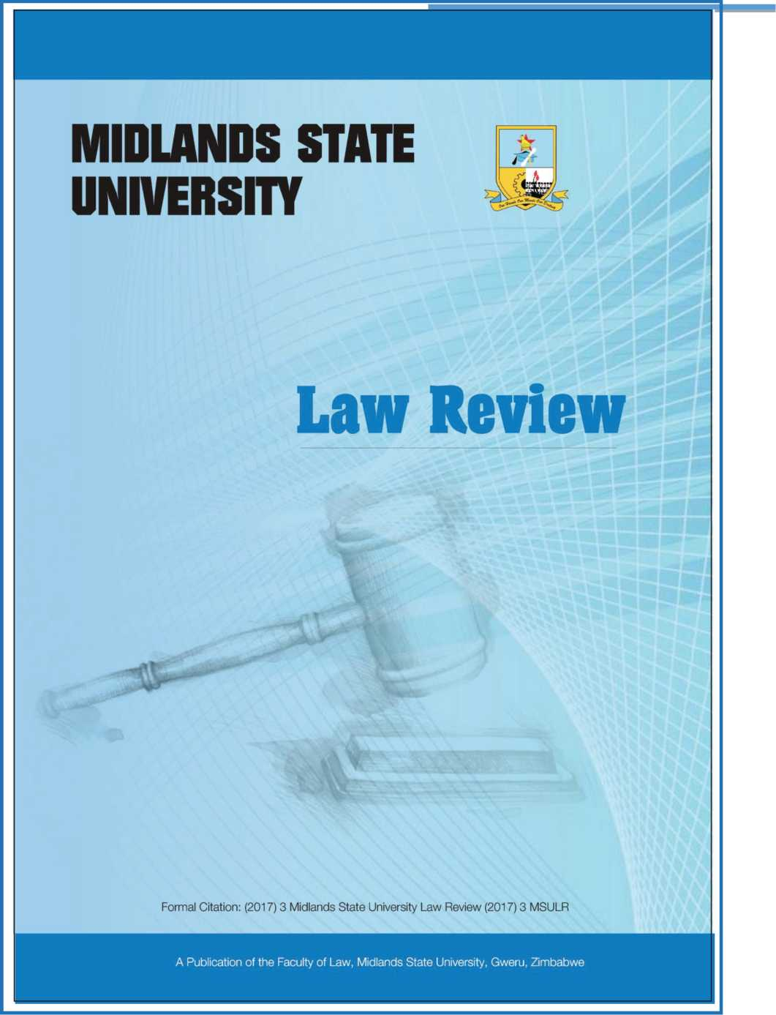

Midlands State University Law Review 2017

A Positive Step Towards Ending Child Marriages: A Review of the Loveness Mudzuru & Anor vs Minister of Justice, Legal & Parliamentary Affairs N.O & Others Case
Blessing Mushohwe*
- Introduction
On the 20th of January 2016, the Zimbabwean Constitutional Court handed down a crucial landmark judgement on an issue that had for long remained unsolved in the fight against child sexual abuse. It outlawed child marriages in the long drawn case of Loveness Mudzuru & Ruvimbo Tsopodzi vs Minister of Justice, Legal & Parliamentary Affairs N.O; Minister of Women's Affairs, Gender & Community Development & Attorney General of Zimbabwe, (hereafter known as the Mudzuru & Tsopodzi case). On this day, Deputy Chief Justice Luke Malaba sitting with a full Constitutional Court bench ruled that any marriage between a man and a woman where one of them is below the age of 18 years is unconstitutional therefore illegal in Zimbabwe. This being a Constitutional Court judgement, it immediately effectively repealed sections of the Marriage Act¹ that allowed for a girl of 16 years and above to get married. It also in effect inserted an age limit of 18 years and above for marriage into the Customary Marriage Act² which was silent on the age of marriage and was thus allowing marriage at any age. Even though the judgement affects both boys and girls, as was expected, it was widely celebrated as a victory for the girl child since the issue of child sexual abuse and indeed child marriages in Zimbabwe is a gendered issue that almost affects girls only. The judgement therefore stands out as a landmark ruling that brought to an end an undesirable dark era where child sexual abuse and exploitation was being perpetrated and promoted under the guise of marriage.
*LLB (Fort Hare, South Africa) LLM (University of KwaZulu-Natal, SA); LLD Candidate (Wits, South Africa); Child Rights, Policies and Development Professional, Zimbabwe.
¹ [Chapter 5:11}.
² [Chapter 5:07}.
7

Midlands State University Law Review 2017
This article reviews the judgement with a view to unpack how it affects the socio-legal landscape of Zimbabwe. The review begins with an overview of the issue of child marriages in Zimbabwe and globally. The cumulative events that built up to the judgement are explored next, followed by an overview of the facts of the case. Further, an analysis is conducted of the critical issues dealt with in the judgement, highlighting the important legal aspects raised and dealt with and how they are going to affect the Zimbabwean society. The review ends with insights on the work ahead for the various stakeholders as regards the actual practical implementation of the judgement so that child marriages are effectively ended for good.
- Background to Child Marriages Globally and in Zimbabwe
Child marriage is the entering into a marriage union between two people, one of whom is below the age of 18 years. The age of 18 is the benchmark age for the definition of a child according to the s 81(1) of the Constitution of Zimbabwe³; Article 2 of the African Charter on the Rights and Welfare of Children (hereafter referred to as the ACRWC)⁴ and Article 1 of the Convention on the Rights of the Child (hereafter referred to as the CRC)⁵. According to an African Union communique in 2014 while launching its campaign on ending child marriages, "Every year, about 14 million adolescent and teen girls are married, almost always forced into the arrangement by their parents".⁶ UNICEF further states that more than 700 million women alive today were married before their 18th birthday and more than one in three (about 250 million) entered into the union before age 15.⁷ Child marriages statistics, particularly in Africa are at times alarmingly high as shown by the child marriages map below.
³ Constitution of Zimbabwe (Amendment No 20) Act of 2013.
⁴ Entered into force on 29 Nov 1999. Ratified by Zimbabwe on the 19th of January 1995.
⁵ Adopted by General Assembly Resolution 44/25 of 20 Nov 1989. Ratified by Zimbabwe on the 11th of September 1990. The CRC, however, sadly leaves room for domestic legislation to set an earlier age of attaining majority status. This is undesirable as it opens up opportunities for State parties to promote violation of various children's rights by simply lowering the age of majority in the particular country. The ACRWC notably and commendably does not allow for any such deviations by State parties from the set age of 18 years.
⁶African Union Communique titled 'Campaign To End Child Marriage In Africa: Call To Action' on the continental launch of the African Union Campaign to End Child Marriage in Africa, 29 May 2014, African Union Commission Headquarters, Addis Ababa, Ethiopia.
⁷ United Nations Children's Fund, 'Ending Child Marriage: Progress and Prospects', (2014), UNICEF, New York.
8

Midlands State University Law Review 2017
Figure 1: Child Marriage Prevalence across Africa⁸
According to the Zimbabwe Multiple Indicator Cluster Survey (MICS) Report of 2014, child marriages in the country as of 2014 stood at 32.8%.⁹ This translates to about one in three women and less than 1 in 20 (3.7 %) of men aged 20-49 who were first married or in union before age of 18 years. The Report further states that young people aged 15-19 years currently married or in union were 24.5% and 1.7% for women and men, respectively. Some Districts in Zimbabwe are, however, worse off on child marriages than others as shown in the District map below.
⁸Map derived from the Afri-Dev.lnfo 2016 Report, 'Multisectoral Information. Data, Research & Evidence for Health, Population, Human & Sustainable Development'.
⁹ Zimbabwe National Statistics Agency (ZIMSTAT), 'Multiple Indicator Cluster Survey 2014: Key Findings Report', (2014), Zimbabwe, p35-36.
9
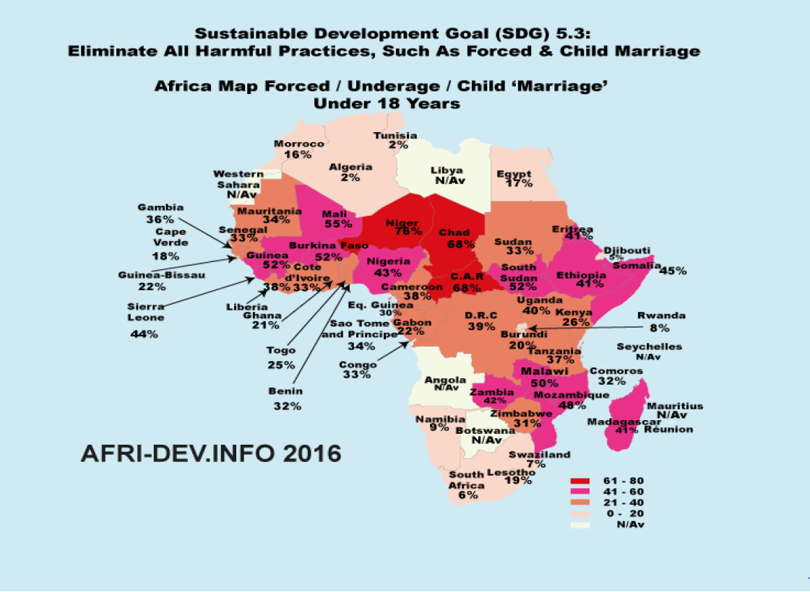
Midlands State University Law Review 2017
Figure 2: District Prevalence Mapping of Teenage (Child) Marriages in Zimbabwe¹⁰
Map 9: Proportion of female teenage (15-19 years )married population,
Zimbabwe, 2012
While the 32.8% national prevalence may sound meagre as compared to other countries such as Niger (76%), Malawi (50%) and Mozambique (48%) among others, the percentage is still disturbingly high, particularly considering the fact that it is essentially representing sexual abuse and exploitation of children which should not be tolerated at all, not even when the prevalence rate is relatively low.
Prior to the Mudzuru & Tsopodzi case under review, the issue of child marriages had never reached the courts as a subject nor had it been properly dealt with by the legislature. Two important pieces of law however, need mention as far as they seemed to entrench the practice of child marriages in Zimbabwe. First is the Marriage Act¹¹ which only prohibited
¹⁰ UNICEF and Zimbabwe National Statistics Agency, 'Descriptive Child and Youth Atlas: Zimbabwe: A District and Ward Analysis of Social Determinants', (2015), Zimbabwe, p25,
¹¹ Note 2 above.
10
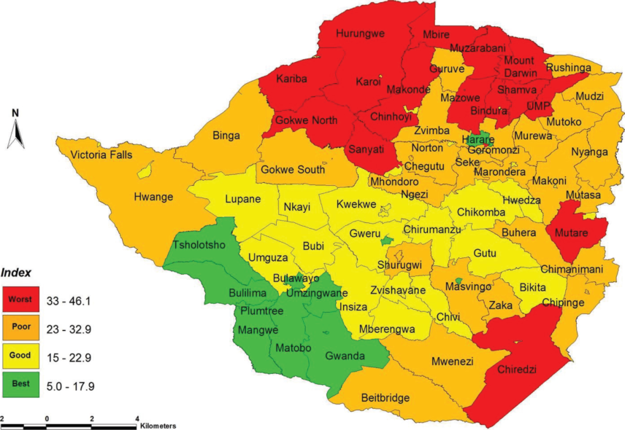
Midlands State University Law Review 2017
marriage of girls below the age of 16 meaning that between 16-18 years, a girl child could be married. Section 22(1) of the Act stated that: "No boy under the age of eighteen years and no girl under the age of sixteen years shall be capable of contracting a valid marriage except with the written permission of the Minister, which he may grant in any particular case in which he considers such marriage desirable:...". With this, in an absurd discriminatory manner, the law in Zimbabwe effectively allowed marriage of girls (children) when they reach the age of 16 years, despite the fact that they are still considered children below 18 years. As if this was not enough, the same clause still allowed even those children below the age of 16 years to be married provided the consent of the responsible Minister of Home Affairs has been granted, thus effectively entirely removing an age limit for marriages in the country. The age limit of 16 years for marriage in the Act was possibly in alignment with various laws on children existing in Zimbabwe then that defined a child as a person under the of 16 years.¹²
The Customary Marriage Act¹³ which regulates customary marriages in Zimbabwe, on the other hand, simply did not have an age limit for customary marriages. Such silence meant that marriage of children could be allowed under customary law, including for those below the age of 16 years. The only limit would seemingly only come through criminal law that considers any sexual act with a child below the age of 12 years to be rape.¹⁴ Section 64(1) states that both girls and boys less than 12 years are irrefutably presumed to be incapable of consenting to sexual intercourse or act of any type while s 65 defines this as rape. With sexual intercourse being a material component of a marriage, criminal law effectively made the marriage of girls below 12 years illegal. For those between 12-16 years, the Criminal Law Code makes such sexual intercourse an offence but albeit, a very light offence popularly known as Statutory Rape.¹⁵
The above therefore meant that children, at least above 12 and below 16 years could be married in Zimbabwe prior to the Mudzuru & Tsopodzi case, with the Minister's consent as dictated by the Marriage Act or at the risk of a Statutory Rape crime which attracted a very
¹² Section 2 of the Child Abduction Act [Chapter 5:05] and section 2 of the Children's Act [Chapter 5:06] among others.
¹³ Note 3 above.
¹⁴ Criminal Law (Codification and Reform) Act [Chapter 9:23] (hereafter known as the Criminal Law Code).
¹⁵ Section 70 of the Criminal Law Code.
11

Midlands State University Law Review 2017
lenient sentence of usually a fine or community service and still allowing the perpetrator to marry the child which again could be considered a mitigatory factor in sentencing. This of-course would only happen where a case had been reported to the Police, which wasn't the case with many cases especially in the rural areas where acceptance of committing the sexual act and agreeing either to marry the child and/or to pay bride-price would be considered as a first preferred alternative before involving the Police.
Besides the above laws that seemed to perpetuate child marriages, the lone piece of legislation that could be used to prosecute child marriages was the Domestic Violence Act which in section 3(l)(l) defines child marriage as one of the abusive, discriminatory or degrading practices on women derived from cultural or customary rites or practices.¹⁶ Section 4 of the same Act prescribes a sentence of a fine or imprisonment for a period not exceeding ten years for such. While this was possible, the litigation was possibly going to meet the same challenge of defining a child, which according to Acts mentioned earlier, prior to the new Constitution of 2013, would have been a person below 16 years of age. Thus using the Domestic Violence Act, a gap would still have remained for those above 16 but below 18 years. Again, all this would similarly have required a Police report first, which as discussed earlier, was normally overshadowed by family negotiations.
In brief, the child marriages story of Zimbabwe prior to the Mudzuru & Tsopodzi case was therefore that some laws seemed to encourage it either expressly or by omission while others prohibited it but lacking adequate substantive details of the crime, thereby discouraging any possible litigation thereto. Scope at law for challenging child marriages was therefore very limited. As such, the most that had been done on child marriages prior to the landmark judgement was from advocacy groups that have for long been calling for the end to the atrocious act of marrying children, which they rightfully described as sexual abuse and exploitation.
- The Case and Events Building Up to the Judgement
The long drawn constitutional challenge on child marriages in Zimbabwe in the Mudzuru & Tsopodzi case started in October 2014. As summarised in the judgement, the two applicants
[Chapter 5:16}.
12

Midlands State University Law Review 2017
were young women aged 19 and 18 years respectively who approached the Constitutional Court in terms of s 85(1) of the Constitution of Zimbabwe.¹⁷ Their case was basically that the fundamental rights of girl children were being infringed upon through the subjecting of girls to early marriages which is also sometimes known as child marriages. While the Respondents to the case opposed the submissions of the Applicants, the points raised will not be repeated but will be canvassed below as part of the analysis of the judgement, which mainly centre on the Respondents' opposition. It should however, be noted here that while there may have been a temptation for the Respondents not to oppose, particularly considering the clear blatant sexual exploitation inherent in child marriages, it is commendable that they opposed. It is their points in opposition that allowed the expansive and elaborate response from the Judge, which is now being celebrated as enriching to domestic jurisprudence on child rights and indeed as having shed light on some otherwise ambiguous and grey provisions of the Constitution of Zimbabwe.
From the Applicants' and the Respondents' submissions, the Court determined that four (4) issues for determination were apparent as follows:
- Whether or not the applicants have, on the facts, locus standi under s 85(1) (a) or s
85(l)(d) of the Constitution to institute the proceedings claiming the relief they seek.
- If they are found to have standing before the Court, does s 78(1) of the Constitution
set the age of eighteen years as the minimum age for marriage in Zimbabwe.
- If the answer to issue No. 2 is in the affirmative; did the coming into force of ss 78(1)
and 81(1) of the Constitution on 22 May 2013 render invalid s 22(1) of the Marriage Act [Chapter 5:05] and any other law authorising a girl who has attained the age of sixteen to marry.
- If the answer to issue No. 3 is in the affirmative; what is the appropriate relief to be granted by the Court in the exercise of the wide discretion conferred on it under s 85(1) of the Constitution.
These issues are discussed in the analysis below.
¹⁷ The Applicants were represented by Mr Tendai Biti. His thorough canvassing of issues and presentation is commended as his arguments constituted most of the DCJ's reasoning and ruling.
13

Midlands State University Law Review 2017
During the period immediately prior to the beginning of the Constitutional Court challenge in October 2014 up to the delivering of judgement on the 20th of January 2016, a number of critical and complimentary events related to child marriages occurred. First were the launch of the African Union Campaign to End Child Marriages in May 2014 and the subsequent adoption of the African Common Position on the AU Campaign to End Child Marriages in Africa in July 2015¹⁸. At the same time in July 2015, the UN Human Rights Council also unanimously adopted a resolution on ending child marriages. Earlier in August 2014, the Zimbabwe Multiple Indicator Cluster Survey (MICS) Report¹⁹ had been released with results showing an increase in child marriages in Zimbabwe. Next was the Motion in the Zimbabwean Parliament to end child marriages in January 2015;²⁰ followed by the meeting of the SADC Parliamentary Forum in Johannesburg in February 2015 and the subsequent drafting of the SADC Model Law on Child Marriages in August 2015.²¹ More importantly however, was Zimbabwe's adoption of and launch of the AU campaign to end child marriages on the 31st of July 2015 which officially confirmed government's willingness to end child marriages in the country.²² The collective result either directly or indirectly was the Constitutional Court ruling in the Mudzuru & Tsopodzi case declaring that child marriages are unconstitutional and therefore unlawful in Zimbabwe. This became a much celebrated landmark judgement in child rights, law and jurisprudence and indeed a deserved victory for those in the child rights sector who are engaged in an enduring fight against sexual abuse and exploitation of children in Zimbabwe.
- Critical Review and Analysis of the Judgement
As expected, the judgement drew a lot of media attention, with various analyses of the
judgement being proffered and published in the local media in the period following the
¹⁸ Note 7. See also the adopted African Common Position on the AU Campaign to End Child Marriage in Africa,
- July 2015.
¹⁹ Zimbabwe National Statistics Agency (ZIMSTAT), 'Multiple Indicator Cluster Survey 2014: Key Findings Report', (2014), Zimbabwe, p35-36.
“Parliament of Zimbabwe, Votes and Proceedings of the National Assembly, Second Session-Eighth Parliament, 28th January, 2015.
²¹ 'Moves to stop child marriages', Newsday, 02 February, 2015; 'SADC child model law takes form', Newsday, 17 August, 2015.
²²'Launch of AU campaign on ending child marriages in Zimbabwe', Zimbabwe Broadcasting Corporation, 31 July 2015.
14

Midlands State University Law Review 2017
ruling.²³ However, for academic purposes, an academic analysis is proffered in this
The 56 page judgement delivered by DCJ Malaba impressively unpacks and interprets the Constitutional law of Zimbabwe as regards marriage law and indeed the concept of a child in relation to marriages.
The Respondents in their opposing papers had alleged that the Applicants had no right to approach the court (had no locus standi) because:
- They had not alleged that their own rights as individuals had been infringed by child marriages since none of them had alleged that they entered into any marriage (civil or customary) with the man that made them pregnant; and
- They had not satisfied the provision of acting in the public interest because they had not given any names of children whose fundamental rights had been infringed through the alleged child marriages and on whose behalf the Applicants purported to act.
This contention by the Respondents became crucial in the Mudzuru & Tsopodzi case as it afforded the court the opportunity to reflect on the issue of locus standi and public interest litigation.
Locus standi is a Latin word that means 'a place to stand'. In law, it means the right to bring an action or to challenge some decision, to be heard in court, or to address the Court on a matter before it.²⁴ It is the ability of a party to demonstrate to the court sufficient connection to and harm from the law or action challenged to support that party's participation in the case.²⁵ Locus standi on enforcement of fundamental human rights and freedoms is dealt with in s 85(1) of the Constitution of Zimbabwe. The DCJ commendably
²³ 'Thoughts on the Constitutional Court Landmark Judgement on Child Marriages', AlexMagaisa.Com, 21 January 2016; ‘A Key Step to Ending Child Marriages', Sunday Mail, 24 January 2016; ‘A Note on the Child Marriage Judgement', Prepared by Derek Matyszak, Senior Researcher, Research and Advocacy Unit, January 2016.
²⁴ J Law & E.A Martin, Oxford Dictionary of Law: Seventh Edition, (2009), p333.
²⁵ 'Locus Standi Law & Legal Definition', http://definitions.uslegal.eom/l/locus-standi/.
paper.
3.1.
Locus Standi
15

Midlands State University Law Review 2017
took the opportunity to elaborate on 2 grounds of locus standi as stated in s 85(l)(a) and
In explaining the first ground for locus standi, the DCJ quoted the Chief Justice Chidyausiku who in Mawarire v Mugabe NO and Others²⁶ stated that:
"Certainly this Court does not expect to appear before it only those who are dripping with the blood of the actual infringement of their rights or those who are shivering incoherently with the fear of the impending threat which has actually engulfed them. This Court will entertain even those who calmly perceive a looming infringement and issue a declaration or appropriate order to stave the threat, more so under the liberal post-2009 requirements."
The principle highlighted here and being commendably confirmed in the Mudzuru & Tsopodzi case is that locus standi is not only satisfied when one has already been a victim of an infringement. Contrary to the suggestions of the Respondents, the Applicants in the child marriage case or in any other case need not prove actual victimhood and certainly need not wait for an infringement to occur first before they can approach the court. A perceived threat of an infringement can entitle them to approach the court. While this was simply confirmation of an already established principle from Mawarire, the confirmation is crucial in that it cements the general acceptance of the principle and indeed shows consistency of the court in following its own previous pronouncements on crucial principles, as is required by rules of judicial precedent.
The DCJ went on to discuss the opposition of locus standi based on s 85(l)(d) which relates to acting in the public interest. As a definition, according to Budlender, "Public interest law focuses on the wider public interest rather than the more private interests of a particular individual, and to this extent, it represents an approach which is different from traditional legal aid programmes".²⁷ He further explains that public interest litigation thus is an attempt to produce a legal decision which will affect the conditions and circumstances of a whole class or group.
²⁶ CCZ 1/2013 at p8.
²⁷ G Budlender, 'On Practising Law' in H Corder (Ed) Essayson Law and Social Justice (1988), p322.
16

Midlands State University Law Review 2017
While correctly noting the erroneous interpretation proffered by the Respondents, the DCJ argues that s 85(1) in its entirety must be accorded a liberal, broad and generous interpretation rather than the narrow traditional conception of locus standi. In this regard, he aptly states that, "The object is to overcome the formal defects in the legal system so as to guarantee real and substantial justice to the masses, particularly the poor, marginalised and deprived sections of society." This critical view by the DCJ is supported by Cote & Van Garderen, who while commenting on s 38 of the South African Constitution²⁸ (which is similar to s 85(1) of the Constitution of Zimbabwe) said,
"This clause has expanded the traditional law of locus standi by a considerable amount. No longer must the person who was directly affected by the unlawful action find the resources to bring a matter to court. This provision allows for a number of parties, particularly those with far more resources than the average person, to bring such an application."²⁹
The reference made by the DCJ to 'justice to the masses, particularly the poor, marginalised and deprived sections of society' is particularly important to child rights law especially considering the disempowered and vulnerable status of children in society who for various obvious reasons, cannot normally stand up for their own rights. In this regard, the DCJ rightfully describe children as falling "into the category of weak and vulnerable persons in society."
The endorsement of public interest litigation in such matters affecting vulnerable and poor masses allows even for institutional applicants to bring matters in the public interest for social justice of the less privileged or those that cannot afford the usually high costs of litigation. Even more welcome is the DCJ's insistence on keeping 'concepts such as "public interest" broad and flexible to develop in line with changing times and social conditions
²⁸ Act 108 of 1996.
²⁹ D Cote & J Van Garderen, 'Challenges to public interest litigation in South Africa: External and internal challenges to determining the public interest', (2011) Vol 27, South African Journal for Human Rights, pl71. See also J Brickhill & M DuPlessis, 'Two's company, three's a crowd: Public interest intervention in investor- state arbitration (Piero Foresti v South Africa), (2011) Vol 27 South African Journal for Human Rights, pl52 where they state that “Our courts are increasingly recognising that certain matters cannot be resolved simply as disputes between the parties, but must necessarily involve the perspectives and voices of organisations or entities that may not have a direct legal interest in the matter in the traditional sense, often asserting (their conceptions of) the public interest."
17

Midlands State University Law Review 2017
reflective of community attitudes". Indeed with this clarity on public interest litigation, the country will most likely witness an increase in such cases even beyond the realm of child rights, particularly in the socio-economic rights front, especially from NGOs. This has been and still is the case in South Africa.³⁰ Matyszak therefore aptly sums up the commendable elaboration on locus standi by the DCJ by stating that, "It is also to be celebrated that the judgment eschews its erstwhile, stifling and restrictive approach to "locus standi" and now allows an individual to approach the court to enforce the rights of the public at large, even where the individual has no self-interest in the matter."³¹
Still on locus standi, the DCJ also makes a critical observation-a/m-reminder that "constitutional invalidity of existing legislation takes place immediately the constitutional provision with which it is inconsistent comes into force." As noted by Magaisa, while the much talked about realignment of the law with the Constitution is crucial, there is no need for waiting for the process to complete for one to hold an offensive provision invalid.³² Similarly, one need not wait for the Constitutional Court to pronounce constitutional invalidity of a provision in domestic legislation, as was the case in the child marriages case under review. Where the Constitutional provision is clear and requiring no further interpretation or clarity, the apparent inconsistent provision in the domestic law becomes automatically invalid from the date the Constitution or the particular Constitutional provision came into effect.
- Reading of International Law into Zimbabwean Cases
Another much celebrated positive of the Mudzuru & Tsopodzi case is the expansive reference by the DCJ to international law in the form of international treaties and conventions as they relate to the issue of child rights and child marriages. In its attempt to interpret s 78(1) as read with s 81(1) of the Constitution of Zimbabwe, the court resorted to
³⁰ Cases such as the Government of the Republic of South Africa v Grootboom 2001 (1) SA 46 (CC); Mazibuko v City of Johannesburg 2010 (4) SA 1 (CC); Leon Joseph v City of Johannesburg 2010 (4) SA 55 (CC); Treatment Action Campaign v Minister of Health (No 2) 2002 (5) SA 721 (CC)); President of the Republic of South Africa v Modderklip Boerdery (Pty) Ltd 2005 (5) SA 3 (CC); Port Elizabeth Municipality v Various Occupiers 2005 (1) SA 217 (CC); Residents of JoeSlovo Community, Western Cape v Thubelisha Homes 2010 (3) SA 454 (CC); Occupiers of 51 Olivia Road v City of Johannesburg 2008 (3) SA 208 (CC), among others which all took the form of public interest litigation.
³¹ D Matyszak (n24 above).
³² A Magaisa (n24 above).
18

Midlands State University Law Review 2017
international law. This is justified by s 46(l)(c) of the Constitution of Zimbabwe which requires a court to take into account international law and all treaties and conventions to which Zimbabwe is a party to when interpreting any provision of the Constitution contained in the Declaration of Rights.
In this regard, the DCJ begins by acknowledging the place and obligations of Zimbabwe in the international community by virtue of ratification of certain international conventions and treaties. He first notes the CRC and ACRWC and highlights the state's obligation "to protect and enforce the rights of the child as enshrined in the relevant conventions to ensure that they are enjoyed in practice."³³ The Convention on the Elimination of All Forms of Discrimination Against Women,³⁴ is also referred to in as far as it relates to its Committee recommending the appropriate age of marriage as 18 years. In giving a background to the marriage laws as set in s 22(1) of the Marriage Act, the DCJ further makes reference to the Universal Declaration of Human Rights (UDHR)³⁵ and the Convention on Consent to Marriage, Minimum Age of Marriage and Registration of Marriages.³⁶
While avoiding the risk of restating the otherwise very thorough and clear analysis of the relevant international law by the DCJ, it is important to highlight the willingness of the highest court in Zimbabwe to embrace the guidance of international law in interpreting constitutional provisions, including importantly, on children's rights which have not had as many cases being decided at such high levels. While the use of international law in interpreting domestic laws is not necessarily new in Zimbabwe, the continued application particularly at the level of the Constitutional Court is critically important for assessing consistency of the courts in use of international law and indeed in creating and developing precedent that can continue to be followed by other lower courts.³⁷ It indeed reflects Zimbabwe's willingness to have its human and child rights practices measured against international norms and standards. This is aptly stated by the DCJ when he said, "...the court has to take into consideration the current attitude of the international community of which Zimbabwe is a party, on the position of the child in society and his or her rights." This is
³³ This is a requirement of Article 4 and 1 of the CRC and ACRWC respectively.
³⁴ Adopted by the United Nations General Assembly Resolution 34/180 of 18 December 1979.
³⁵ Adopted by the United Nations General Assembly Resolution 217 (III) of 10 December 1948.
³⁶ Opened for signature and ratification by General Assembly Resolution 1763 A (XVII) of 7 November 1962.
37 ,
A Magaisa (n24 above).
19

Midlands State University Law Review 2017
crucial also for similar interpretation of legal provisions both in and outside the child rights sector.
- Other Positives from the Judgement
In so using international law, the DCJ was attempting to give meaning to s 78(1) as read with s 81(1) of the Constitution of Zimbabwe. The Respondents in interpreting the meaning of the 'right to found a family' in s 78(1) had argued for a literal meaning which would not equate it to the right to enter into a marriage. The DCJ however, commendably went for a generous, purposive interpretation of the provision, coming to the conclusion that, "Section 78(1) of the Constitution sets eighteen years as the minimum age of marriage in Zimbabwe. Its effect is that a person who has not attained the age of eighteen has no legal capacity to marry. He or she has a fundamental right not to be subjected to any form of marriage regardless of its source. The corollary position is that a person who has attained the age of eighteen years has no right to marry a person aged below 18 years."
The above interpretation of s 78(1) immediately struck down sec 22(1) of the Marriage Act or any other law, practice or custom authorising a person, both male and female less than 18 years of age to marry or to be married. As clarified by the DCJ, this includes any unregistered customary law union or any other union including one arising out of religion or religious rite.³⁸
Indeed the generous, purposive interpretation taken by the DCJ here commendably drives the point home that technical issues of strict legal interpretation should not be allowed to lead to negative consequences of perpetrating child sexual abuse and exploitation. By further declaring that "There are no provisions in the Constitution for exceptional circumstances", the DCJ effectively plugs any possible gaps that may otherwise later be used by adults to again prey on children for sexual satisfaction under the guise of marriage. In so doing, he decisively mirrors the Zimbabwean society's abhorrence of child sexual abuse and exploitation and by so proclaiming, legally puts the matter of child marriages to rest.
³⁸ This covers the various religious and customary practices that were major drivers of child marriages such as 'kuzvarira, kuripa ngozi, sara pavana, kuputswa, inter alia, among the Shona people.'
20

Midlands State University Law Review 2017
This approach taken by the DCJ is however, criticised by Matyszak who identifies some situations where marriage with an under 18 should have been allowed in 'special circumstances' such as when the husband is 19 and the girl is 17 years.³⁹ He argues that such a marriage will be "in the best interests of a child, including a soon to be born or recently bom child" between the two teenage couple as is recognised by Article 2 of the United Nations Convention on the Consent to Marriage, Minimum Age for Marriage and Registration of Marriage.⁴⁰ Persuasive as this argument may sound, it is submitted that the blanket ban adopted by the DCJ is commendable as it serves among others, as a deterrence measure from irresponsible sexual conduct even between teenagers that may lead to the need for marriage.
The DCJ is also commended for departing from a purely legalistic reasoning but rather acknowledging the inter-disciplinary nature of the issue of child marriages through proffering a detailed description of the social consequences of child marriages.⁴¹
- The Work Ahead for Full Implementation of the Judgement
While the judgement is certainly welcome for child protection and indeed for development of jurisprudence around child rights, a deeper look into it and the environment in which it will have to be enforced brings one to a rude awakening that while this single battle has been won, there is still a whole lot more to be done if the country is indeed going to truly end child marriages.
  - Alignment of the Relevant Laws to the Child Marriages Ban
As regards the law itself, there clearly is need now for stakeholders to begin lobbying the powers that be, particularly legislators to urgently amend the relevant statutes in the form of the Criminal Law Code, the Children's Act (which is currently under review), the Marriage
³⁹ D Matyszak (n24 above).
⁴⁰ Note 37 above.
⁴¹ It should ideally be the duty of every judicial officer to consider and canvass the social implications of any legal issue that they may be dealing with where applicable. This emphasizes the fact that laws do not operate in a vacuum but are implemented in society and indeed regulate day-to-day social interactions, among others. The canvassing of such social consequences of a given legal issue is especially important at Constitutional Court level where the court plays a critical role of giving meaning to constitutional provisions that reign supreme in the country.
21

Midlands State University Law Review 2017
Act and the Customary Marriage Act among others to reflect the unlawfulness of child marriages as a criminal offence and to clearly indicate the sanctions attached to those who contravene the said law.⁴² This refers to legal sanctions for violation of the new ban and the development of an enforcement mechanism for the ban on child marriages.⁴³
As of now, sanctions against child marriages can practically only be enforced through s 3(l)(i) and 4 of the Domestic Violence Act as discussed earlier.⁴⁴ While the Domestic Violence Act can be used alone in the meantime, there evidently is need for alignment of all other statutes mentioned above to unambiguously criminalise the act for avoidance of any doubt. In so legislating, sanctions against violations of the ban must be for those that actually marry children below the age of 18 years, those that arrange and take part in the marriage of such a child and those that may have forced (in various ways) the child to get married. It may also be important to consider sanctions against those that know of a child marriage having taken place and decide not to report it to the Police within a reasonable stated period of time.
  - Possible Review of the Age of Consent to Sex
Still on laws, the judgement opened up other areas which now require urgent consideration such as the issue of Age of Sexual Consent which remains at 16 according to the Criminal Law Code as discussed earlier⁴⁵ while marriage is now at 18 years. Without a review of the age of consent to sex, a situation arises where children may now have unrestrained sex from 16 years with whomever, even a 60 year old man, and even possibly getting pregnant from such as long as the sexual activity does not lead to marriage. This certainly defeats the purpose of the child marriages ban in the sense that the sexual manipulation and exploitation that used to happen in child marriages can still continue as before with the only difference being that this time around the man no longer fears being forced to marry the girl because the law does not allow it. Such a situation may have the undesirable effect of
⁴² Work in this regard seems to be underway. See ‘MPs sign petition to ban child marriages', Herald, 18 March 2016; and 'Zimbabwe ramps up pressure on parents to stop child marriages', News24Zimbabwe, 18 March 2016. Civil Society Organisations such as WLSA, ZWLA, and ROOTS among others have also been assisting with the drafting of the new Marriage Bill.
⁴³ A Magaisa (n24 above).
⁴⁴ See part 2 above.
⁴⁵ Ibid.
22

Midlands State University Law Review 2017
encouraging sexual irresponsibility among men who are now protected from forced marriage by the law.
Where the sexual acts result in pregnancy, the judgement may also have the effect of further putting the burden of care for the newborn child on the girl's parents. Such may force especially traditional rural societies to revert back to the arrangement of marrying off the child, albeit in secrecy, thereby continuing sexual abuse of children. In considering solutions to the issue of age of consent, caution must however, be exercised on the temptation to simply raise the age of sexual consent to 18 years as this has its own practical complications and possible child rights violation issues thereto.
The law also needs to be clear on what happens if the child marriage is between children who are both under 18 years and are both mutually agreeing to it. While a child at law cannot consent to any form of marriage, it may happen that two children aged 17 enter into such a union. Clarity is thus needed on how the law will handle this.⁴⁶
In light of the above, it is clear that lawmakers still have work to do in order that the child marriages ban is legally enforceable without the apparent negative side effects especially on the girl child that it mainly seeks to protect.
- Community Outreach and Education on Child Marriages
Having dealt with the law, it should however, also be critically understood that generally laws alone do not end criminal activities. In-fact, it is human nature to become defensive and rebellious towards rules and the same should be expected even of this noble judgement against child marriages. There is need from the onset to understand that this ban will have to be enforced in communities where children are often married off mostly by their elders in religious settings or in traditional practices for various reasons. As such, community engagement, advocacy and awareness in such settings should become the crux of the fight against child marriages. A crucial part of this awareness raising should be explaining the
⁴⁶ The Mudzuru vs Tsopodzi judgement outlaws situations of an adult over 18 marrying a child below 18 years. The scenario of children marrying each other, most likely in an unregistered customary marriage, which is common particularly in rural areas, is not addressed. Since the marriage between the two children is evidently invalid, does the law envisage a situation where the children will be arrested for child marriage? If so clarity is needed on processes and sanctions for entering into such a marriage for the two children.
23

Midlands State University Law Review 2017
unlawfulness of child marriages and the legal consequences for those who commit the offence in terms of the Constitution and other aligned laws mentioned above. But more importantly, the awareness and advocacy should emphasise on developing an understanding with communities on what child marriage is, why it is wrong for a child to be married, why it is good for a child not to get married early and critically what can community members do when they witness child marriages in their communities. With such a community engagement approach, community members participate in ending child marriages out of understanding and appreciation of the benefits of not marrying off children, rather than out of fear of the law alone.
- Conclusion
The above was a review of the much celebrated Constitutional Court ruling on child marriages in the Mudzuru & Tsopodzi case. While it was noted that Zimbabwe's child marriages problem is relatively lower as compared to other African countries, the problem still needs vigorous efforts to totally end it since it is part of the many atrocious forms of sexual abuse and exploitation on children. The judgement by DCJ Malaba was commended for expounding on critical issues such as the question of locus standi and public interest litigation. With the clarity given, possibilities for more cases involving social justice for the poor and vulnerable are opened, including for further advancement of child rights. The reading of international law into the interpretation of Constitutional provisions in Zimbabwe was also highly commended as progressive as it pushes the country to international standards in child rights and other human rights norms. While the judgement is indeed progressive, some gaps with the law that undesirably appeared as a result need to be plugged, particularly as regards the age of consent to sex. Ultimately, for the ban to be effectively implemented in the short and long-term, community outreach and education on child marriages needs to be at the centre of all interventions.
24

