KENNETH TSIWO

And

TROUBLE CHIKWATI

And

LAST MABVUREGUDO

Versus

POLICE SERVICE COMMISSION

And

COMMISSIONER GENERAL OF THE ZRP

IN THE HIGH COURT OF ZIMBABWE
BERE J
BULAWAYO 18 OCTOBER 2016 AND 16 JANUARY 2020

Court Application for Review

M. Mpofu for the applicant
Ms R. Hove, for the respondent
BERE J: This is an application for review which was made possible by the order granted by my brother MATHONSI J (as he then was) on 14th day of April 2016 in which he granted the applicant condonation to file the application.
The three applicants are ex-serving members of the Zimbabwe Republic Police who lost their employment after being charged and convicted of contravening section 35 of the Schedule to the Police Act [Chapter 11:10], in that they were alleged to have acted in an unbecoming manner or manner prejudicial to good order or likely to bring discredit to the force .Put simply, the charge was that the three applicants had connived with a Zambian national vendor to smuggle goods from Zambla into Zimbabwe.
It was the applicants’ conviction on this charge which subsequently led to their dismissal from the force by the 2nd respondent.
The basis of this review application is that when the applicants appeared before a single officer as per section 34 of the Police Act they protested at the short notice given to them to prepare for the hearing. They alleged that they were denied the statutory period of 72 hours to enable them to adequately prepare for their trial.
The applicants also alleged that they were denied legal representation and that their trial was fast tracked leading to their conviction. They alleged as one of their grounds for review, that when they appealed to 1st respondent against the decision of the 2nd respondent to discharge them from the force they were denied an opportunity to be heard in direct violation of the audi alteram partem rule.
As regards their conviction by the single officer which triggered a chain of misfortune against them the applicants alleged that the conviction itself was so irregular in its defiance of logic that no officer reasonably applying his mind would have accepted the evidence as being enough to sustain their conviction.
The notice of opposition to this application was filed by the former Commissioner General of the Zimbabwe Republic Police, Augustine Chihuri.
The deponent maintained that the evidence presented to the trial officer was enough to sustain a conviction and that the conviction was proper. He further argued that the mere fact that the applicants may have been acquitted in the criminal case proceedings did not mean that the disciplinary proceedings should have produced the same results as the applicants’ conduct was reprehensible.
In his affidavit the deponent relied on the evidence of the ZIMRA officials which ultimately led to the conviction of the applicants.
The second respondent accepted that the 1st respondent as an Appeal Board did not afford the applicants an opportunity to be heard before it but used its discretion not to call the parties and proceeded make its decision on the papers filed.
The second respondent further argued that the decision to discharge the applicants from the force was above board and should not be questioned given the evidence that was presented. Commenting on the short notice for the hearing before a single officer complained of by the applicants, the deponent stated that the applicants agreed to have their case heard at short notice. He made reference to page 1 of annexures A; B and C which he alleged were attached to his notice of opposition. Unfortunately these papers were not part of his papers. He said that the applicants had accepted a short notice for the hearing of their case, and that they therefore waived their rights
As regards the denial of legal representation alleged by the applicants, the deponent denied this was so and stated that the applicants chose to conduct their hearing unrepresented. Again, as support of this, he made reference to page 1 of annexures ‘A’, ‘B’ and ‘C’, documents which unfortunately were not annexed to his notice of opposition.
The second respondent refuted the assertion by the applicants that they were denied their right to appeal by the trial officer who is alleged to have told them that they had no prospects of success.
The first port of call by the applicants’ counsel, Mr Mpofu in court was to attack the conviction of the applicants by the single officer which set in motion the subsequent proceedings against the applicants.
Counsel argued that the decision by the trial officer to convict the applicants was grossly irregular and unreasonable in its defiance of logic that no reasonable decision maker could have arrived at it. His submissions were anchored inter alia on the provisions of section 68 of the Republic of Zimbabwe Constitution which states:
“(1) Every person has a right to administrative conduct that is lawful, prompt, efficient, reasonable, proportionate, impartial and both substantively and procedurally fair.”
Counsel argued that the evidence that was presented to the trial officer could not possibly have sustained the applicants’ conviction and that the decision to convict was grossly irregular. His position was that the evidence given by Tonderai Mushonge (the ZIMRA officer) and Edith Mukombwe relied on by the trial officer actually exonerated the applicants of any wrong doing. I entirely agree as I will indicate later in this judgment.
Applicants’ counsel further argued that the allegation of denial of legal representation made against the trial officer is not something this court must take lightly It is a serious violation of the applicants’ constitutional rights and so is the denial of the applicants of their right to appeal.
Counsel also argued that by being charged in the criminal court and subsequently being subjected to a disciplinary hearing before a single officer the applicants were subjected to double punishment or to what he termed double jeopardy.
In response Ms R. Hove who appeared for the respondents argued that there is a clear distinction between a criminal prosecution and disciplinary proceedings which the applicants seem to miss. She dismissed the whole idea of double jeopardy and argued disciplinary proceedings are a necessary evil in the police force for they help to foster discipline within the force. I agree.
She also submitted that since the attack in these review proceedings were centered on the conduct of the trial officer, it would have been neater to cite him as a party in the review proceedings. She was however quick to concede that this omission was not fatal to the proceedings since the record of proceedings had been made part of the review proceedings.
Counsel further argued that the mere fact that the conviction may have been based on insufficient evidence is not a good ground for review as it is not supported by section 27 of the High Court Act which details those cases that call for review.
The respondent’s counsel reiterated what the notice of opposition stated that the applicants waived their right to have their case heard within 72 hours as provided for by accepting service of the papers on 24 June 2009 which required them to appear before the single officer on 25 June 2009. She said that if the applicants did not want short service they should have declined to accept the service on 24 June 2009.
On the question of legal representation, she argued that there was nothing on record showing that the applicant indicated to the trial officer that they required legal representation. On the allegations that the appellants were denied the right to appeal by the trial officer respondents’ counsel argued that the record of proceedings did not show that such a thing happened and therefore the court must make a finding that it never happened.
Ms Hove concluded her argument by urging the court to reject in toto everything said by the applicants which was not supported by the filed transcribed record of proceedings. In so arguing counsel relied on the position taken by my brother MAKONESE J in the case of Boma and Another v Commissioner General of Police and Another where the learned judge held that where the transcript of proceedings from a disciplinary hearing captures all the material evidence regarding procedure and evidence, the applicant has a duty to prove the contrary.
I now wish to deal with the evaluation of the submissions made in this review application guided by the contentious issues raised by the parties in this case.
The applicants are in the situation they are today because of their convictions on a charge of contravening section 35 of the schedule to Police Act Chapter 11:10. This charge was anchored on the alleged conduct of the applicants in conniving with a Zambian national to smuggle goods into the country.
To sustain the charge there was heavy reliance on the evidence of the ZIMRA official Tonderai Mushonge and the Zambian national, Edith Mukombwe. The evidence of these two witnesses is captured in the record of proceedings from page 73 to 77. After these two witnesses gave their evidence, a verdict of guilty was pronounced. Incidentally no reasons for this verdict were given.
The applicants alleged that the decision to convict them was so irregular in its defiance of logic that the conviction should not have been made in the first place. When challenged under cross-examination Tonderai Mushonge did not confirm that the applicants had smuggled the goods in question. The closest he could say was:
“From a statement I gathered that they were intending to proceed into Zimbabwe with dutable goods improperly declared.

Based on that, I issued a notice of seizure”. (sic)
Throughout his testimony, this witness never testified that the applicants smuggled goods into the country. This was a key witness for the prosecution of the applicants. The witness did not disclose the name of the person who told him that the applicants intended to smuggle the goods into Zimbabwe and that person did not testify.
There was no evidence given to the effect that the applicants had crossed the ZIMRA check point with the goods. If anything, the uncontroverted evidence by the applicants was that they had stopped their vehicle before the ZIMRA check point awaiting Edith Mukombwe to come and declare her goods. As for sweet potatoes, there was unchallenged evidence that these were duty free commodities.
When giving her evidence in chief Edith Mukombwe stated among other things the following;
“The CID then said I and SU members were going to be arrested because the vehicle wanted to pass through without proper procedures taken by ZIMRA officials” (my emphasis)

None of the witnesses who testified against the applicants confirmed that any smuggling took place. It is clear that when the 2nd respondent made reference to the applicants having smuggled goods in his notice of opposition he was merely speculating on things that he did not know and issues that were not supported by the given evidence.
The evidence led suggests that the owner of the goods Mukombwe only paid duty for the goods and was never prosecuted for smuggling.
The conviction of the appellants on the strength of the evidence led in this trial represents a serious miscarriage of justice. This case reminds me of the remarks made by GILLESPIE J in the case of State v Jojo Mberi where he commented on the court’s duty as follows:
“In my estimation this is a classic example of the court massaging the evidence in order to have it fit a preconception. That is not the way to do things. It should scarcely need saying that one must examine the evidence first, and see what it proves, rather than arriving at a preconception first, and see whether it can, no matter how, be supported.”
Clearly the trial officer could not have convicted the applicants on such scanty evidence. Indications are that he had decided to convict the applicants irrespective of what the evidence was. Such officers are dangerous to the administration of justice.
The applicants must therefore be believed when they stated that the proceedings before the single officer, bad as they were, were the primary cause of their discomfort and ought not to stand because they were anchored on nothing. These include the decision of the 2nd respondent and that of the 1st respondent. If these two respondents had properly addressed their minds to the trial proceedings they would have been able to save justice as opposed to perpetrating an evil decision.
It is true that the bulk of the issues raised by the applicants concern the alleged irregularities committed by the trial officer and that he was not cited in these proceedings. I would not take this omission hard on the applicants because initially they were not represented.
However, despite this omission, it must have been quite clear to the respondents that they could not have been able to effectively rebut the serious allegations raised by the applicants against the trial officer without securing a rebuttal affidavit from him. It was not for the 2nd respondent to speak on behalf of the trial officer through his opposing affidavit. I am afraid to say that the bulk of the 2nd respondent’s affidavit was devoted to explaining the ideal situation in the police force as opposed to dealing with the pointed allegations against the trial officer.
Thus when a serious allegation was made against the trial officer that he denied the applicants legal representation, surely it was not for the 2nd respondent to blindly jump to the defence of the trial officer but for the trial officer to file a rebuttal affidavit.
This takes me to consider another very essential issue that has assumed centre stage in these proceedings. There was a repetitive argument raised by the respondents’ counsel. which was to the effect that whatever was raised by the applicants, which did not appear in the record of proceedings as transcribed must be rejected by the court. In so doing she sought to rely on the remarks of my brother MAKONESE J’s views as already stated earlier on
In so arguing counsel for the respondents misses one fundamental issue. The bulk of the proceedings if not all concerning police disciplinary proceedings are mechanically or manually recorded. This is an archaic way of recording proceedings .In my view, it is both myopic and unrealistic for anyone to think that proceedings recorded in this manner would be able to capture all the material issues in a hearing. In practice some trial officers are known not to record all the proceedings for a variety of reasons.
I take judicial notice of the fact that years ago, the courts in this country used to face challenges to do with distorted records of proceedings transcribed from mechanically recorded proceedings by trial officers. It was not until the introduction of recording machines that sanity started to prevail. It was only then that reliance was placed on transcripts of such records of proceedings.
I believe it is a lazy argument for anyone to suggest that a transcribed record of proceedings extracted from a mechanically recorded system represents the whole truth and must be religiously accepted.
The court must be concerned when it is suggested by the respondents that the applicants waived their statutory entitlement of 72 hours in preference for the hearing of their case the following day after being served with notices of hearing. Under normal circumstances why would an officer facing allegations that threaten his professional life and livelihood do that?
The court must equally be concerned when allegations of denial of an opportunity to engage legal counsel of the applicants’ choice are raised because that amounts to a violent assault on the constitution of this country.
Again, this court’s view is that when such allegations are made against the trial officer, the best response must not come from the 2nd respondent in this case but from the trial officer himself. It is quite curious that the trial officer’s affidavit is conspicuously missing from these proceedings. Its absence seriously weakens the respondent’s case and in my view the benefit of doubt must be given to the applicants.
When the applicants specifically allege that the trial officer denied them the right to appeal, it cannot be the responsibility of another senior officer in the comfort or discomfort of his office to devise a method of countering such serious allegations. The trial officer must feel inclined to clear his name by providing evidence in rebuttal even if he has not been cited in the application itself. This is because of the seriousness of such allegations and how they negatively impact on his own reputation as an individual.
The applicants raised one other serious allegation against the 1st respondent who they claim denied them the right to be heard when they appealed the decision of the 2nd respondent to discharge then from the force. In response to this allegation the 2nd respondent agreed with the applicants that this is what happened but sought to argue that the 1st respondent had correctly used its discretion to decide the applicants’ fate without giving the applicants an opportunity to argue their case. In my view, nothing could be worse than this. The rules of natural justice demand that even a murderer must be heard first before he is condemned. The 2nd respondent cannot exhibit misplaced pride by justifying a violation of one of the pillars of our sound administrative systems – the audi alteram partem rule.
The view that I take is that administrative functionaries must not clandestinely make decision of far reaching consequences against affected parties without hearing such individuals. In this regard, I could not do more than re-state what GLADSTONE J observed in Jansen Van Ransburg NO v Minister of Trade and Industry NO when he stated:
“In modern states it has become more and more common to grant far reaching powers to administrative functionaries. The safeguards provided by the rules of procedural fairness are thus all more important … observance of the rules of procedural fairness ensures that an administrative functionary has an open mind and a complete picture of the facts and circumstances within which the administrative action is to be taken. In that way the functionary is more likely to apply in a fair and regular manner.”
PATEL J (as he then was) in the case of Zindoga and Or v Minister of Public Service, Labour and Social Welfare and Another weighed in on this principle of fairness by stating:
“It is axiomatic that any party who has a right to interest that is likely to be affected by an administrative decision or which is susceptible to being prejudiced thereby must be heard before that decision is taken. This is dictated by the time honored precept of the common law embodied in the audi alteram partem rule and now codified in the Administrative Justice Act [Chapter 10:28].
If regard is had to the serious allegations raised against the trial officer as well as the other respondents as highlighted, it would be a serious miscarriage of justice if this review application were not to be upheld I take the view that at every stage in the proceedings against the applicants, commencing with their trial before the single officer right up to the time a decision to dismiss them from the force was taken, the applicants were given a raw deal. It does seem to me that there was institutional conspiracy between the trial officer and the 2nd respondent to dismiss the applicants from the force. Unfortunately this conspiracy was endorsed by the 1st respondent by failing to properly analyze the conviction itself. Under normal circumstances, the multitude nature of the irregularities apparent in the proceedings conducted against the applicants would not have escaped the 1st respondent. It remains a puzzle to me why they all missed it.
I want to conclude this judgment by dealing with the issue of double jeopardy which keeps on coming up whenever disciplinary proceedings are taken against members of the police force after criminal proceedings have been conducted against them in terms of the Criminal Law (Codification and reform) Act [Chapter 9:03]. The point has been made in this court that disciplinary proceedings are a necessary evil in maintaining discipline with the force. As observed by MATHONSI J in the case of Felix Sangu versus Commissioner General of Police and two Others and reaffirmed again in this same court in the case of Assistant Inspector Mahleka and two Ors versus The Trial Officer and the Commissioner General of Police,.there is no double jeopardy that arises.
Coming back to this case before me, I am more than satisfied that the application for review be upheld. I therefore make the following order:

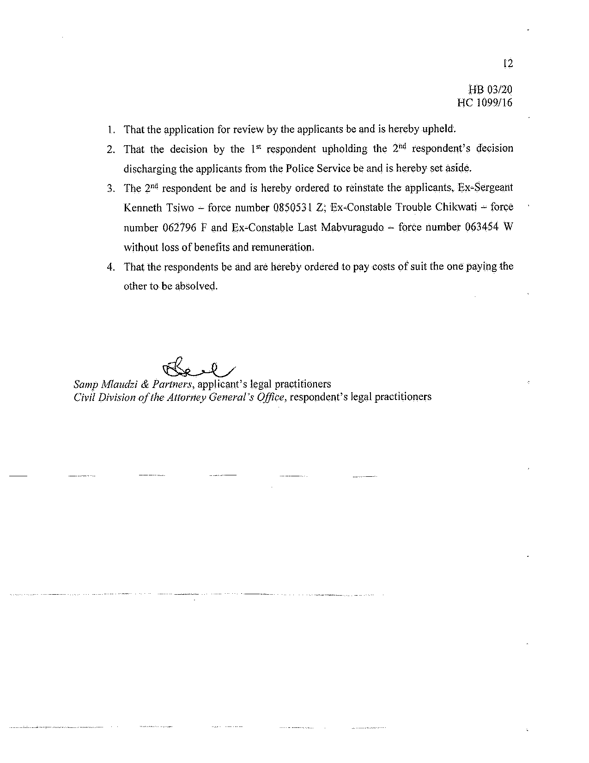

[Amendment (No. 20), 2013]
HB-47-13
HH239/98 at p3-4
2001 (1) SA 29 (CC) par 24
2006 (2) ZLR 10 (H) at p 13D-E
HB-110-16 at page 3
Hb-01-20 at page 7

